Code by Abhishek 191043002

First fit:

#include<stdio.h>

void main()
{
int bsize[10], psize[10], bno, pno, flags[10], allocation[10], i, j;

for(i = 0; i < 10; i++)
{
flags[i] = 0;
allocation[i] = -1;
}

printf("Enter no. of blocks: ");
scanf("%d", &bno);

printf("\nEnter size of each block: ");
for(i = 0; i < bno; i++)
scanf("%d", &bsize[i]);

printf("\nEnter no. of processes: ");
scanf("%d", &pno);

printf("\nEnter size of each process: ");
for(i = 0; i < pno; i++)
scanf("%d", &psize[i]);
for(i = 0; i < pno; i++) //allocation as per first fit
for(j = 0; j < bno; j++)
if(flags[j] == 0 && bsize[j] >= psize[i])
{
allocation[j] = i;
flags[j] = 1;
break;
}

//display allocation details
printf("\nBlock no.\tsize\t\tprocess no.\t\tsize\t\tfragmentation");
for(i = 0; i < bno; i++)
{
printf("\n%d\t\t%d\t\t", i+1, bsize[i]);
if(flags[i] == 1)
printf("%d\t\t\t%d\t\t%d",allocation[i]+1,psize[allocation[i]],(bsize[i]-psize[allocation[i]]));
else
printf("Not allocated");
}
}

Output:
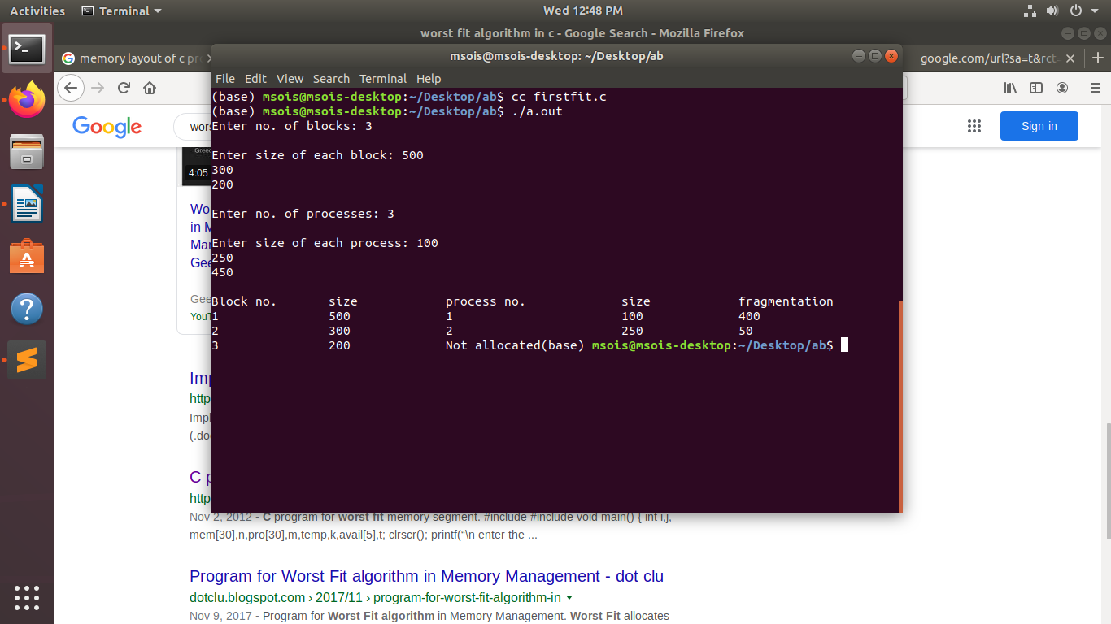

Best Fit:
==========

#include<stdio.h>

void main()
{
int fragment[20],b[20],p[20],i,j,nb,np,temp,lowest=9999;
static int barray[20],parray[20];

printf("\n\t\t\tMemory Management Scheme - Best Fit");
printf("\nEnter the number of blocks:");
scanf("%d",&nb);
printf("Enter the number of processes:");
scanf("%d",&np);

printf("\nEnter the size of the blocks:-\n");
for(i=1;i<=nb;i++)
{
printf("Block no.%d:",i);
scanf("%d",&b[i]);
}

printf("\nEnter the size of the processes :-\n");
for(i=1;i<=np;i++)
{
printf("Process no.%d:",i);
scanf("%d",&p[i]);
}

for(i=1;i<=np;i++)
{
for(j=1;j<=nb;j++)
{
if(barray[j]!=1)
{
temp=b[j]-p[i];
if(temp>=0)
if(lowest>temp)
{
parray[i]=j;
lowest=temp;
}
}
}

fragment[i]=lowest;
barray[parray[i]]=1;
lowest=10000;
}

printf("\nProcess_no\tProcess_size\tBlock_no\tBlock_size\tFragment");
for(i=1;i<=np && parray[i]!=0;i++)
printf("\n%d\t\t%d\t\t%d\t\t%d\t\t%d",i,p[i],parray[i],b[parray[i]],fragment[i]);
}

output :

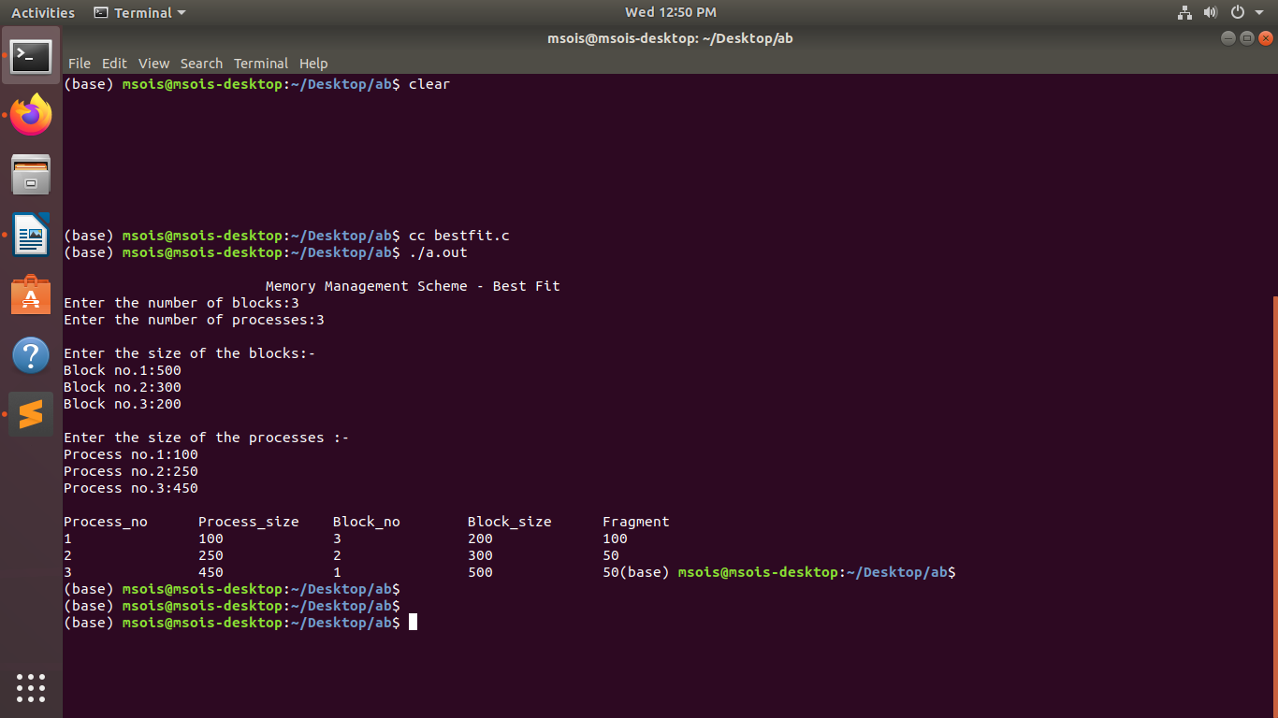

Worst Fit:

#include<stdio.h>

#define max 25
void main()
{
int frag[max],b[max],f[max],i,j,nb,nf,temp;
static int bf[max],ff[max];

printf("\n\tMemory Management Scheme - First Fit");
printf("\nEnter the number of blocks:");
scanf("%d",&nb);
printf("Enter the number of files:");
scanf("%d",&nf);
printf("\nEnter the size of the blocks:-\n");
for(i=1;i<=nb;i++)
{
printf("Block %d:",i);
scanf("%d",&b[i]);
}
printf("Enter the size of the files :-\n");
for(i=1;i<=nf;i++)
{
printf("File %d:",i);
scanf("%d",&f[i]);
}
for(i=1;i<=nf;i++)
{
for(j=1;j<=nb;j++)
{
if(bf[j]!=1)
{
temp=b[j]-f[i];
if(temp>=0)
{
ff[i]=j;
break;
}
}
}
frag[i]=temp;
bf[ff[i]]=1;
}
printf("\nFile_no:\tFile_size :\tBlock_no:\tBlock_size:\tFragement");
for(i=1;i<=nf;i++)
printf("\n%d\t\t%d\t\t%d\t\t%d\t\t%d",i,f[i],ff[i],b[ff[i]],frag[i]);

}

output :

